1.)Write a program to Print Fibonacci Series using recursion.

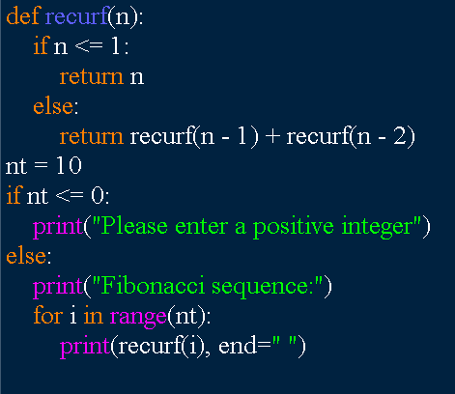



2.) Write a program to check the given no is Armstrong or not using recursive function.

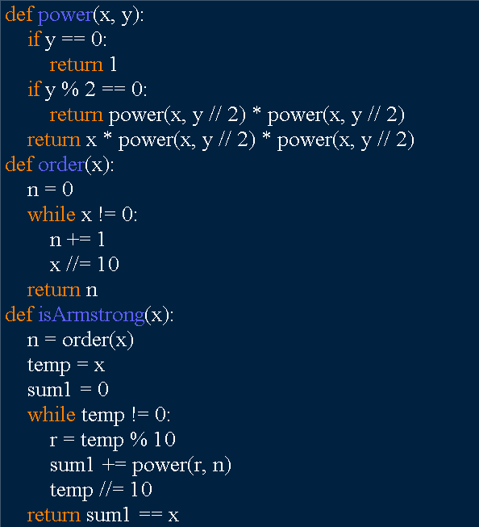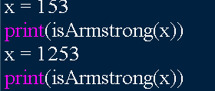  
  
  
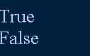  
  
3.) GCD of two numbers using Recursion factorization  
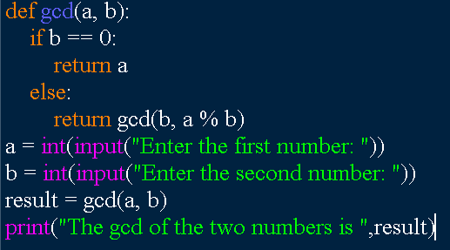  
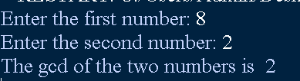  
  
  
4.) finding largest number in an array using recursion.  
  
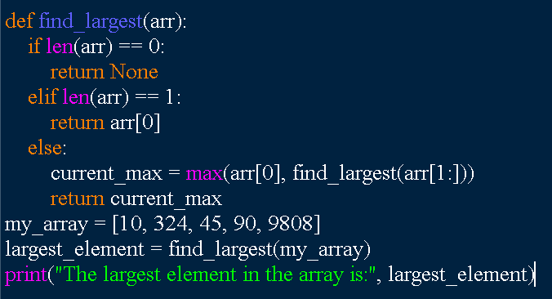  
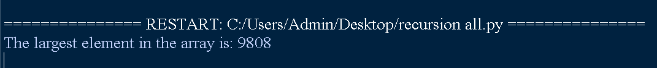  
5.)factorial of a number using recursion  
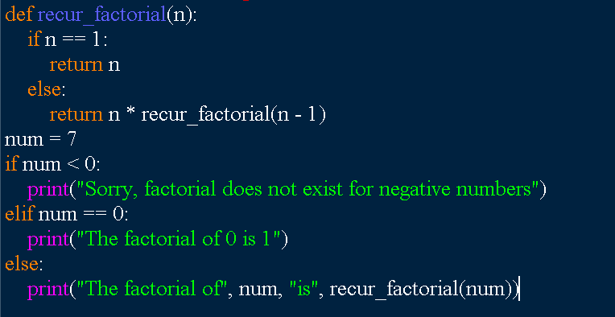  
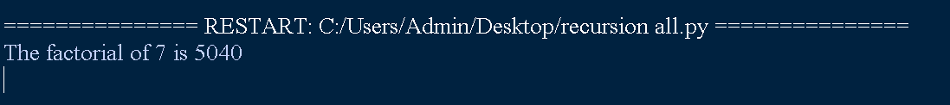  
6.) Write a program for to copy one string to another using recursion  
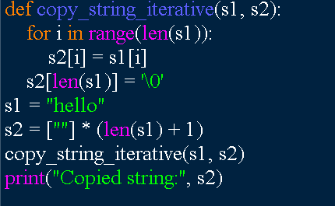  
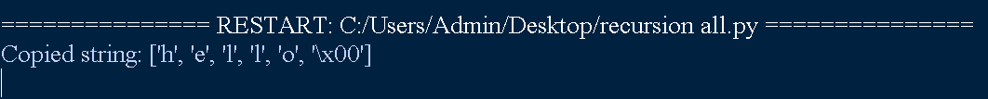  
7.) Write a program to print the reverse of a string using recursion  
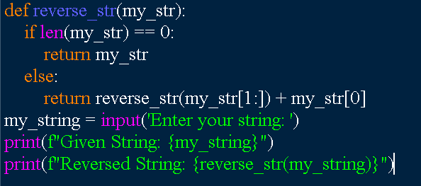  
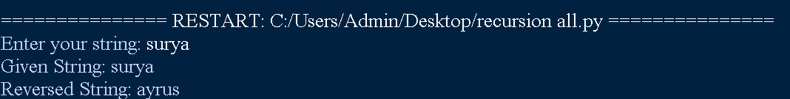

8.) Write a program to generate all the prime numbers using recursion  
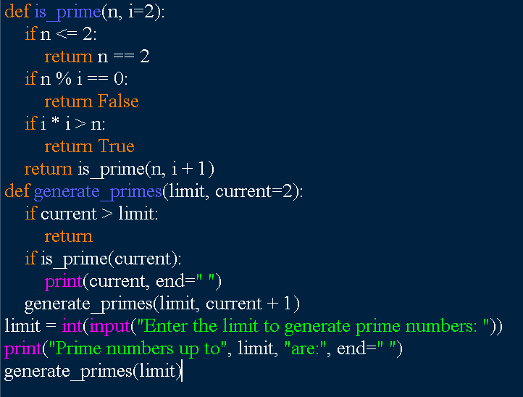  
  
9.) Write a program to check a number is a prime number or not using recursion.  
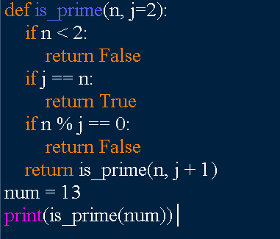  
  
  
10.) Write a program for to check whether a given String is Palindrome or not using recursion  
  
